Remembrance Day 2019 Centenary of the Armistice WW1
On Sunday the 11th November, 2018 St Dominic’s College Band combined with The Caroline Chisolm College Band and Choir to mark the Centenary of Armistice at Memorial Park, Warragamba. This day marked the 100th anniversary of the Armistice where four years three months and 14 days of brutal conflict finally came to an end in the First World War (1914–18). Almost 62,000 Australians died fighting for our freedom and in service of our nation.
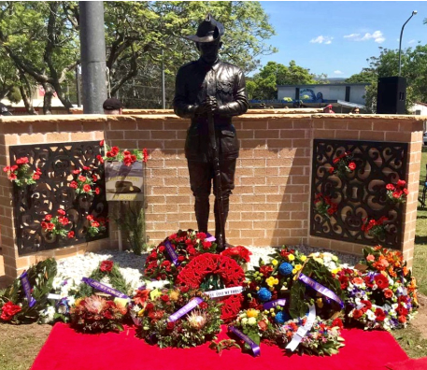
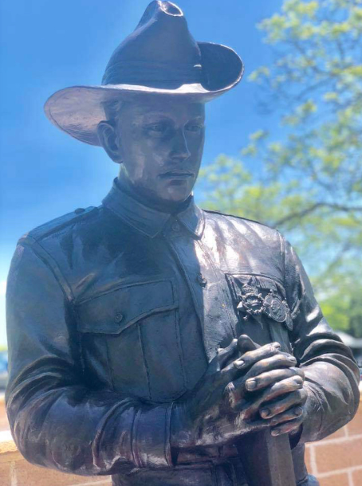
The Ceremony at Warragamba was significant as the community was unveiling a bronze statue (pictured below).

St Dominic’s Band, led by Mr. Chris Wilson, represented the College with pride and, as result of their ability, have been invited by the Warragamba and Districts ANZAC Committee to be a permanent feature at all their important commemorative events including: ANZAC Day, Remembrance Day and the Vietnam Service Day.
Todd Robertson- Social Justice Prefect.
