Using mobile technologies at St Dominic’s College
With numerous education systems and media focussing on the use of Mobile Phones in schools, it is important that you are aware of the College’s Mobility Solution that serves our Learning Statement in providing the highest quality learning environment for your son. Your son does NOT require a mobile phone at St Dominic’s College, however we recognise that as a community many parents prefer that they have a mobile so we have built an environment that maximises this opportunity for learning.

Learning Statement
Learners at St Dominic’s strive to achieve their personal best, self-directed in leading their own lifelong learning.
We are a connected learning community that focuses on the promotion of higher order thinking. Personalised needs are authentically served in a blended learning environment.
The College provides a liberating education, creating opportunities for all its members to be engaged and empowered by learning.

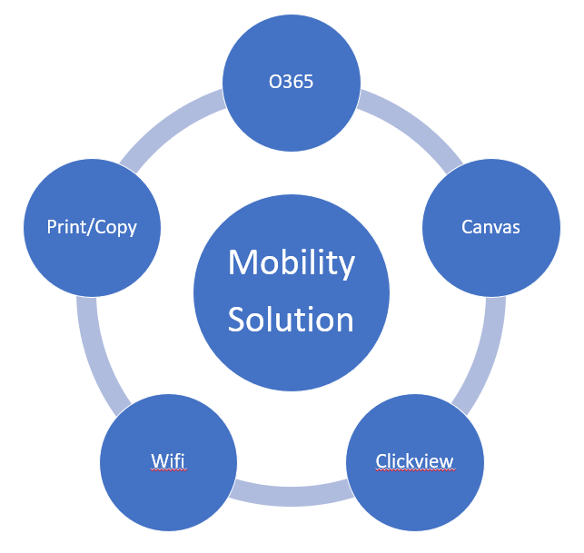
Mobility Solution
In serving our learning statement key features of our Mobility Solution include:
Personal Best: Students access their results 24/7 in understanding their progress and performance throughout the course. They have direct communication with peers and teachers in seeking their personal best via feedback and discussion.
Lifelong Learning: Our students experience a learning environment that they would also access in the home, university and in the workplace. They have access to College Wifi via all mobile devices (laptop/phone) and can use either where best suits and under teacher guidance.
Personalised Learning: The ability to access information, tasks and contacts when and where we need them is an everyday reality. With Canvas (our Learning Management System) students have the ability to move through lessons and learning at a rate that best suits their needs via any device or physical method. Our blended learning environment allows the students and teachers to utlise whatever tools best serve the learning experience, books still play an important role at St Dominic’s College. Students will also be able to print, copy and scan to wherever and whenever they need paper copies to assist them.
Engagement: Numerous ‘learning objects’ (resources designed to deepen understanding) are now available in multimedia format. Our Clickview video streaming platform provides students with an educational ‘Netflix’ experience where videos can be watched and interacted with when and wherever they want with the added benefit of having the video downloaded straight to their phone for viewing. Students aren’t relying on valuable lesson time to watch videos that can only be accessed at school, they can review, preview and interact with these resources in their own time therefore maximising their lesson time with their teachers in engaging in higher order thinking.

What your son has access to via his laptop or phone to assist his learning
Product | Laptop | Phone
Canvas | Web Interface | Student APP  Parent APP  SMS Messages
Office 365 | Office Suite (up to 5 devices)  Email  Onedrive – cloud backup | Office Apps (Unlimited)  Email  Onedrive access
Clickview | Web Interface | APP  Download content
Wifi | College Network | College Network
Print/Copy/Scan | Print and scan | Print

If your son is not making the most of all of these resources or experiencing difficulties please encourage him to visit our IT Helpdesk (in the Edmund Rice Learning Centre) or alternatively contact us at IThelpdesk@stdominics.nsw.edu.au

ICT Use Policies and Procedures
It is imperative that your son learns in a safe environment and the College has developed and educated all students on the appropriate use of technology at the College. In addition we provide a secure and filtered environment where inappropriate content and actions are blocked/monitored.
All policies and procedures can be accessed via: https://www.stdominics.nsw.edu.au/our-learner/learning-and-technology/
Key features of the policies that you should discuss with your son include:
- ‘Hot-spotting’ to a phone to access the internet on College grounds is prohibited. College WiFi is provided to ensure your son is safe.
- The taking of images (photo/video) and publishing of College community members is prohibited (without College authorisation).
- All actions undertaken by devices owned (or provided) by the user and/or their accounts are the responsibility of the user. Any user who suspects their account details are insecure is to contact the IT Helpdesk for assistance.
- All student files are to be saved in Onedrive to ensure copies of all files are stored locally on their device with a copy in the cloud available at all times. This provides an instant rollover for students who require device repairs without loss of critical work being lost.

